http://www.gcsepod.co.uk/school-login/harrowhigh2013students/
click on the link above to set up your account
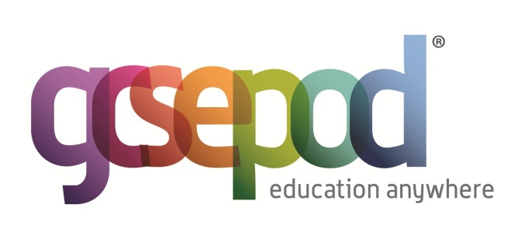

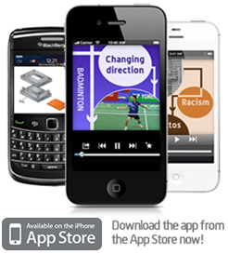
GCSEPod has over 2,500 GCSE specific podcasts which you can watch online or download to your Apple, Blackberry or Android device. GCSEPod is FREE OF CHARGE to all Harrow High School Academy students and staff.
- Covers 15 subjects
- Watch in the car, bus or at school
- Packed with important facts
- Tailored to your exams

